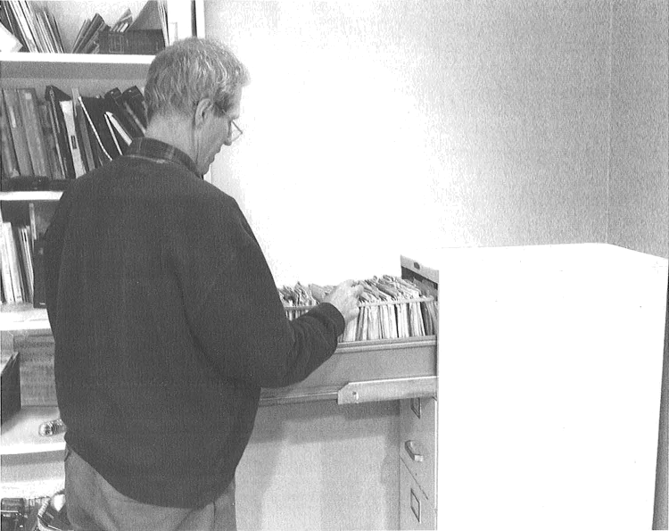1.

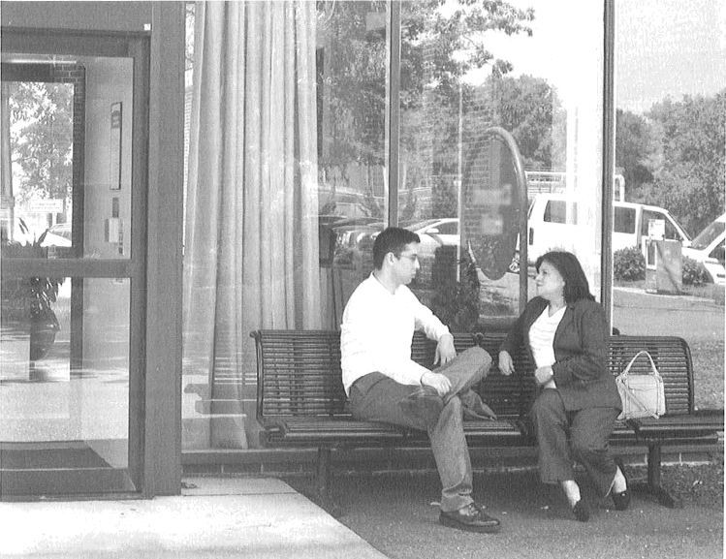2.

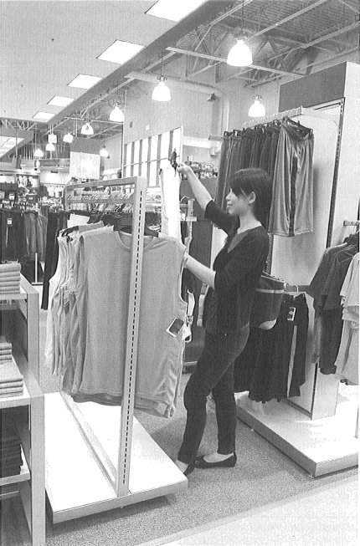3.

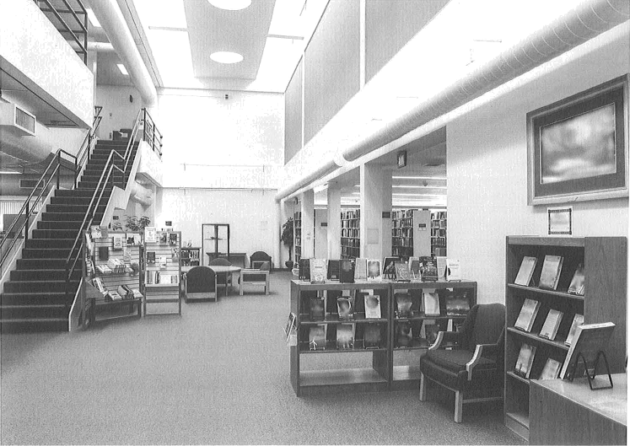4.

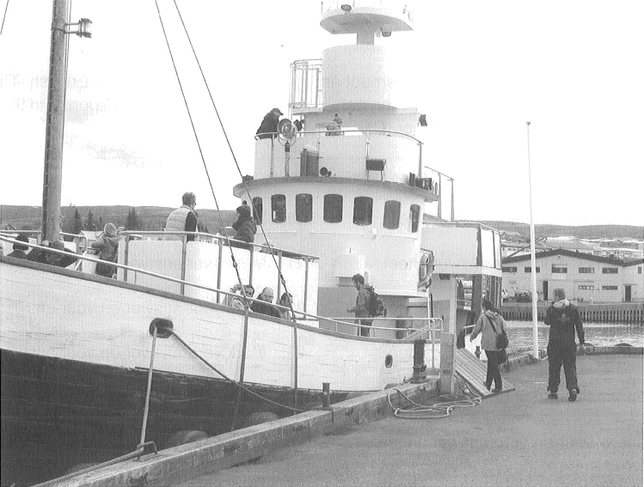

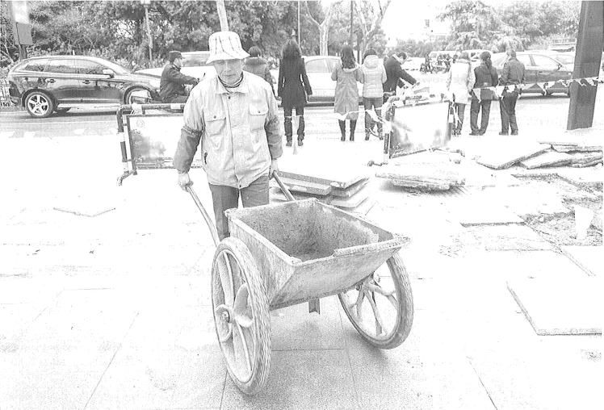6.

PART 2

Directions: You will hear a question or statement and three responses spoken in English. They will not be printed in your test book and will be spoken only one time. Select the best response to the question or statement and mark the letter (A), (B), or (C) on your answer sheet.

1. Mark your answer on your answer sheet.
2. Mark your answer on your answer sheet.
3. Mark your answer on your answer sheet.
4. Mark your answer on your answer sheet.
5. Mark your answer on your answer sheet.
6. Mark your answer on your answer sheet.
7. Mark your answer on your answer sheet.
8. Mark your answer on your answer sheet.
9. Mark your answer on your answer sheet.
10. Mark your answer on your answer sheet.
11. Mark your answer on your answer sheet.
12. Mark your answer on your answer sheet.
13. Mark your answer on your answer sheet.
14. Mark your answer on your answer sheet.
15. Mark your answer on your answer sheet.
16. Mark your answer on your answer sheet.
17. Mark your answer on your answer sheet.
18. Mark your answer on your answer sheet.
19. Mark your answer on your answer sheet.

#### Mark your answer on your answer sheet.

1. Mark your answer on your answer sheet.
2. Mark your answer on your answer sheet.
3. Mark your answer on your answer sheet.
4. Mark your answer on your answer sheet.
5. Mark your answer on your answer sheet.

PART 3

Directions: You will hear some conversations between two or more people. You will be asked to answer three questions about what the speakers say in each conversation. Select the best response to each question and mark the letter (A), (B), (C), or (D) on your answer sheet. The conversations will not be printed in your test book and will be spoken only one time.

##### What does the company most likely produce?

* 1. Print advertisements
  2. Television shows
  3. Computer parts
  4. Musical instruments

1. What department will the man work in?
   1. Accounting
   2. Legal
   3. Human resources
   4. Security
2. What does the man like about his work area?
   1. It is conveniently located.
   2. It has a good view.
   3. It is quiet.
   4. It is nicely decorated.
3. What is the conversation mainly about?
   1. A room reservation
   2. A canceled event
   3. A restaurant recommendation
   4. A misplaced item
4. What does the man need to provide?
   1. A security deposit
   2. A revised schedule
   3. A form of identification
   4. A business address
5. Where does the conversation most likely take place?
   1. At a shopping mall
   2. At a theater
   3. In a sports stadium
   4. On a train
6. Why does the woman say, "The football championship is this afternoon"?
   1. To extend an invitation
   2. To offer encouragement
   3. To give an explanation
   4. To request a schedule change
7. What does the man say he needs to purchase?
   1. Tickets
   2. Clothes

##### Food

* 1. Furniture

1. What problem does the man mention?
   1. Some products are damaged.
   2. Some equipment is out of stock.
   3. A vehicle has broken down.
   4. A delivery error has occurred.
2. What does the woman say is planned for Friday?
   1. A product launch
   2. An inspection
   3. A cooking class

37.

What do the visitors ask for?

1. A refund
2. Better lighting
3. Menu options
4. More chairs

(D) An interview

1. What does the man say he will do?
   1. Transfer a call
   2. Issue a refund
   3. Provide a warranty
   4. Visit a business
2. Where do the speakers most likely work?
   1. At a law office (B} At a supermarket
3. At a medical clinic
4. At a recreation center
5. What are the speakers mainly discussing?
   1. A marketing campaign
   2. A new product
   3. Some budget cuts
   4. Some survey results
6. What does the woman imply when she says, "That would require significant revisions to our scheduling process"?
   1. She doubts a change will be implemented.
   2. She thinks more staff should be hired.
7. What is the woman an expert in?
   1. Gardening
   2. Nutrition
   3. Appliance repair
   4. Fitness training
8. What does the woman recommend?
   1. Substituting ingredients
   2. Using appropriate tools
   3. Changing an exercise routine
   4. Scheduling regular maintenance
9. According to the woman, where can listeners find more information?
   1. On a television show
   2. On a Web site
   3. In a magazine
   4. In a book
10. She needs more time to make a decision.
11. She believes some data is incorrect.
12. Why did the woman miss a meeting?
    1. She was not feeling well.
    2. She was on a business trip.
    3. She was speaking with a client.
    4. She did not receive the invitation.
13. What is the woman confused about?
    1. The details of an assignment
    2. A reimbursement process
    3. The terms of a contract
    4. A travel itinerary
14. According to the man, what should the woman do?
    1. Reset the password for her computer
15. What does the woman say about the man’s job performance?
    1. He is respected by his colleagues.
    2. He always meets his deadlines.
    3. He has good ideas for new projects.
    4. He has increased company profits.
16. What does the woman ask the man to do?
    1. Attend a trade show
    2. Join a leadership council
    3. Mentor a colleague
    4. Accept a new position
17. When will the speakers meet again?
    1. Tomorrow
    2. Next week
    3. Next month
    4. Next quarter
18. Talk to the organizer of the meeting
19. Consult the electronic version of a

##### document

1. Research the history of an account
2. What does the man ask the women about?
   1. The types of projects assigned
   2. The backgrounds of the applicants
   3. The status of training materials
   4. The location of an orientation
3. What does the man say about last year’s internship program?
   1. Some new products were developed.
   2. Some information was unclear.
   3. There were not enough supplies.
   4. There were a large number of applicants.
4. What does the man say he is pleased about?
   1. The summer schedule
   2. The careful planning
   3. The deadline extension
   4. The approval process
5. What type of business does the woman work for?
   1. A moving company

62.

63.

|  |  |
| --- | --- |
| Catering Company | Cost |
| Café Delight | 11,250 |
| Corner Deli | t 1,400 |
| Golden Eagle | $950 |
| Star Restaurant | 1850 |

What type of event are the speakers discussing?

1. A shareholders’ meeting
2. A press conference

##### A job fair

1. A product demonstration

What problem did the woman experience with one of the restaurants?

1. An unhelpful staff member
2. A poorly cooked meal
3. A billing error
4. A delivery delay
   1. A real estate agency
   2. An insurance firm
   3. An equipment rental service
5. What is the woman concerned about?
   1. Shipping delays
   2. New regulations
   3. An increase in competition
   4. A shortage of staff
6. What does the woman emphasize about her company?
   1. The affordable prices
   2. The number of branch offices
   3. The user-friendly Web site
   4. The customer service
7. Look at the graphic. How much will the lunch most likely cost?

(A) $1,250

(B) $1,400 (C) $950 (D) $850

## How Do We Find Employees?

Museum Map

Floor 4

*Architecture*

Floor 2

*Sculpture*

Floor 3

*Paintings*

Floor 1

*Photography*

### Corrlpan Web Sit 10%

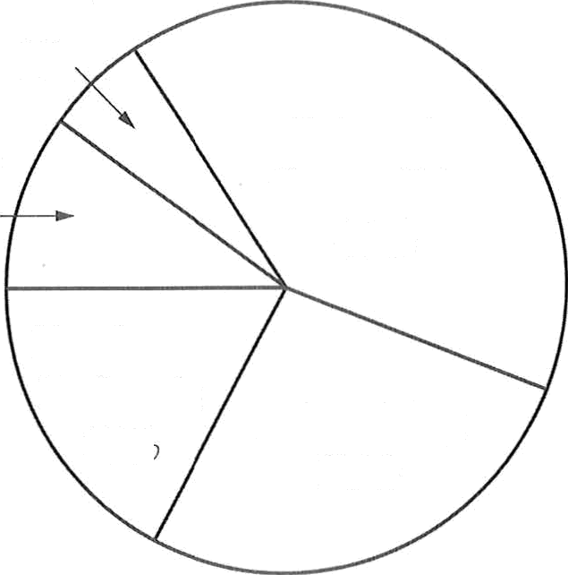

Other 6%

y e

University Ciii'eer Fairs 40%

Employee Referrals 17fi

Adveiti.sing 27%

1. Look at the graphic. On which floor will the man meet his friends?

##### Floor 1

* 1. Flooi 2
  2. Floor 3
  3. Floor 4

1. What will happen at the museum this summer?
   1. A workshop will be offered.
   2. A special exhibit will open.
   3. Concerts will be held in the garden.
   4. Some galleries will be renovated.
2. Why does the woman suggest using the stairs at the back of the museum?
   1. They are nearby.
   2. They offer a good view.
   3. They were recently added.
   4. They are not crowded.
3. What does the woman want to do?

##### Make travel arrangements

* 1. Revise a budget

##### Change recruiting tactics

* 1. Give a lecture

1. Look at the graphic. Which method does the man suggest using?

##### University career fairs

* 1. Advertising
  2. Employee referrals
  3. Company Web site

1. What does the woman suggest the man do?

### Design a questionnaire

* 1. Renew a contract
  2. Work with a colleague
  3. Interview a job candidate

PART 4

Directions: You will hear some talks given by a single speaker. You will be asked to answer three questions about what the speaker says in each talk. Select the best response to each question and mark the letter (A), (B), (C), or (D) on your answer sheet. The talks will not be printed in your test book and will be spoken only one time.

1. At which event is the announcement being 77.

made?

* 1. A book fair
  2. A product launch
  3. A technology conference
  4. A charity fundraiser

Who most likely is the speaker?

1. An investment banker
2. A city official
3. A food scientist
4. A restaurant manager
5. According to the speaker, what can some listeners do tomorrow?
   1. Go on a tour
   2. Attend an opening ceremony
   3. Participate in a focus group
   4. Win a prize
6. What are the listeners instructed to do?

#### Use an alternate entrance

* 1. Register in advance
  2. Complete a survey
  3. Meet at a designated location

1. What product does Castillo manufacture?
   1. Jewelry
   2. Clothing
   3. Art supplies
   4. Backpacks
2. According to the speaker, what will happen next week?
   1. Some new equipment will be installed.
   2. A corporate office will relocate.
   3. New menu items will be available.
   4. Seasonal employees will begin work.
3. What does the speaker warn listeners about?

#### Preparing orders carefully

* 1. Wearing proper attire
  2. Recording hours accurately
  3. Taking inventory daily

1. Why is the speaker calling?
   1. To register for a training session
   2. To request help with a project
   3. To book a meeting room
   4. To get updated customer information
2. Why does the speaker say, “Just look at the 81.

color selection in these samples”?

#### To introduce a new manufacturing technique

* 1. To assign a task
  2. To express disappointment
  3. To support a decision

What does the speaker imply when she says, "it wasn't my idea”?

1. She knows a change is inconvenient.
2. She thinks a colleague deserves credit.
3. She would like the listener’s opinion.
4. She is going to explain a new procedure.
5. What will Hae-Rim do?
   1. Present financial information
   2. Share competitor data
   3. Analyze survey results
   4. Introduce advertising layouts
6. What does the speaker ask the listener to do?

#### Order business cards

* 1. Check a mailbox
  2. Revise a report
  3. Reserve a booth

What will the company do beginning on June 1 ?

1. Accept reservations online
2. Provide service to a new location
3. Offer a customer loyalty program
4. Lower its express shipping rates
5. What was the speaker supposed to do this morning?
   1. Interview a job applicant
   2. Attend a meeting
   3. Pick up a client
   4. Lead a tour group
6. According to the speaker, what must customers do in order to ship a vehicle?
   1. Show proof of ownership
   2. Provide an extra set of keys
   3. Purchase additional insurance
   4. Get a mechanical inspection
7. What transportation problem does the speaker mention?
   1. A road has been closed.
   2. A bridge is under construction.
   3. A train service is unavailable.
   4. A flight has been delayed.

85.

86.

What does the speaker indicate about the call?

1. It will be redirected to a different department.
2. It will be answered in the order in which it was received.
3. It may be several minutes until a representative answers.
4. It may be recorded for future use.

Who is the intended audience for the talk?

1. Theater patrons
2. Costume makers
3. Ticket sellers
4. Stage musicians
5. What does the speaker suggest?
   1. Inviting other colleagues
   2. Posting a notice
   3. Holding a phone conference
   4. Having lunch together
6. What industry does the speaker work in?
   1. Renewable energy
   2. Computer technology
   3. Publishing
   4. Real estate
7. What does the speaker imply when he says, “hundreds of businesses have signed up”?
   1. He is worried about meeting client
8. What does the speaker mention about the play?
   1. It is very long.
   2. It is set in the past.
   3. There are many characters.
   4. There is a waiting list for tickets.
9. What will take place in five weeks?
   1. A photography session
   2. A dinner reception
   3. A fashion show
   4. A dress rehearsal

demands.

1. He expects an industry to start changing.
2. The listeners should choose his company.
3. The listeners will receive a list of contacts.
4. What will the listeners see in the video?
   1. A virtual tour
   2. An award-acceptance speech
   3. Product features
   4. Installation instructions

Name Background



Feedback Survey

|  |  |
| --- | --- |
| Cleanliness | A A A A  4 stars |
| Location | 4 stars |
| Staff friendliness | A A A A A  5 stars |
| COSt | 3 stars |



SOlhtlOhS Stock

*ndverlisin ut your jin$ei tips*

Image

Tagline

Who is the message most likely for?

1. A fitness instructor
2. A data analyst
3. A gym member
4. A marketing expert

What does the speaker say he has e-mailed the listener?

1. A discount voucher
2. Driving directions
3. A fitness magazine
4. Class schedules

Look at the graphic. Which category does the speaker request more information about?

1. Cleanliness

##### Location

1. Staff friendliness
2. Cost
3. Where is the talk most likely taking place?
   1. At a business class
   2. At a software training session
   3. At a department meeting
   4. At a client presentation
4. Look at the graphic. Which part of the logo does the speaker discuss first?
   1. The name
   2. The background
   3. The image
   4. The tagline
5. What will the listeners do next?
   1. Break into small groups
   2. Write down some ideas
   3. Read an article
   4. Check a Web site

#### This is the end of the Listening test.

**READING TEST**

In the Reading test, you will read a variety of texts and answer several different types of reading comprehension questions. The entire Reading test will last 75 minutes. There are three parts, and directions are given for each part. You are encouraged to answer as many questions as possible within the time allowed.

You must mark your answers on the separate answer sheet. Do not write your answers in your test book.

PART 5

**Directions:** A word or phrase is missing in each of the sentences below. Four answer choices are given below each sentence. Select the best answer to complete the sentence. Then mark the letter (A), (B), (C), or (D) on your answer sheet.

|  |  |  |
| --- | --- | --- |
| 101. York Development Corporation marked the | 105. | The new printer operates more than |
| - -- of the Ford Road office complex with |  | the previous model did. |
| a ribbon-cutting ceremony.  (A) opens |  | 1. quickest 2. quickness |
| 1. opening 2. opened 3. openly |  | 1. quick 2. quickly |
| 102. Staff at the Bismarck Hotel were ------- | 106. | Here at Vanguard Buying Club, help  members find quality merchandise at the |
| helpful to us during our stay. |  | lowest possible prices. |
| 1. quite 2. enough 3. far 4. early |  | 1. us 2. our 3. we 4. ourselves |
| 103. Ms. Luo will explain some possible consequences of the merger with the  Wilson-Peek Corporation. | 107. | Management announced that all salespeople would be receiving a bonus this year, in time for summer |
| 1. proposed 2. proposal |  | vacations.  (A) just |
| 1. proposition 2. proposing |  | 1. as 2. only |
|  |  | (D) by |
| 104. The Springdale supermarket survey ------- |  |  |
| will be released a week after they are | 108. | According to *Florlda Digital Designer* |
| evaluated. |  | *Magazine,* many graphic designers do not |

##### events

* + 1. stores
    2. results
    3. coupons

consider to be traditional artists.

1. it
2. their
3. themselves
4. itself

|  |  |  |
| --- | --- | --- |
| 109. A wooden bridge crossing the wading pond | 115. | Of all the truck models available today, it |
| -- to the hotel’s nine-hole golf course. |  | can be difficult to figure out would |
| 1. prepares 2. leads |  | best suit your company’s needs.  (A) when |
| 1. presents 2. takes |  | 1. why 2. which |
|  |  | (D) where |
| 110. A special sale on stationery on the |  |  |
| Write Things Web site yesterday. | 116. | CEO Yoshiro Kasai has expressed |

1. was announced
2. announced
3. was announcing
4. to announce

111. All produce transported by Gocargo Trucking is refrigerated upon pickup

to prevent spoilage.

1. lately

##### promptly

complete faith in Fairway Maritime’s ------

to deliver the product on time.

1. belief
2. measure
3. problem
4. ability

117. At Derwin Securities, trainees alternate

-- attending information sessions and working closely with assigned mentors.

|  |  |  |
| --- | --- | --- |
| (C) potentially |  | (A) along |
| (D) clearly |  | (B) against |
|  |  | (C) between |
| 112. The Ferrera Museum plans to exhibit a |  | (D) near |
| collection of Lucia Almeida’s most |  |  |
| ----- sculptures. | 118. | Company Vice President Astrid Barretto |
| (A) innovative |  | had no to being considered for the |
| (B) innovation |  | position of CEO. |
| (C) innovatively |  | (A) objected |
| (D) innovate  113. The bank’s cashier windows are open daily |  | 1. objecting 2. objects 3. objection |
| from 8:00 A.M. to 4:00 P.M on |  |  |
| Sundays. | 119. | Belinda McKay fans who are to the |
| 1. except 2. until |  | author’s formal writing style will be surprised by her latest biography. |
| 1. nor 2. yet |  | 1. fortunate 2. readable |
|  |  | (C) comparable |
| 114. Inventory control and warehousing |  | (D) accustomed |
| strategies within the responsibilities of |  |  |
| the supply chain manager. | 120. | The Southeast Asia Business Convention |
| 1. have 2. cover |  | will feature known and respected  leaders from countries across the region. |
| (C) mark |  | (A) widen |
| (D) fall |  | (B) wider |
|  |  | (C) widely |
|  |  | (D) wide |

1. -- the high cost of fuel, customers are

buying smaller, more efficient cars.

* 1. Together with
  2. Instead of
  3. As well as

##### Because of

1. Over the past ten years, Bellworth Medical

Clinic ------- Atlan Protection officers for all

security needs.

* 1. is hiring
  2. were hiring
  3. has hired
  4. was hired

1. The driver will make three to deliver

126. The initial feedback from early buyers of the Sunbell XC2 mobile phone indicates that they found it to use.

1. conveniences
2. conveniently
3. convenience
4. convenient

127. -- space in the bathroom was limited, the contractor managed to fit in two sinks and a shower.

1. Both
2. So that
3. Whether
4. Even though

the package before it is returned to our warehouse.

* 1. attempts
  2. pursuits
  3. aims
  4. experiences

1. We congratulate all Riverside employees, whose effort has resulted in a 20

percent reduction in waste disposal costs.

* 1. collect
  2. collective

##### collects

* 1. collector

1. Andrzej Ptak’s photography Web site will be available online we have finished

organizing and cataloging his work.

* 1. how
  2. once

##### so too

* 1. not only

1. The staff must as much

market-research data as possible before planning the advertising campaign.

* 1. equip
  2. compile
  3. endorse
  4. compose

1. -- a national holiday falls on a Thursday, the Barstow Company allows employees to take off Friday as well.
   1. Even
   2. For
   3. Nearly
   4. Whenever
2. materials for the advanced Farsi

course include an audio CD and a DVD.

* 1. Supplementary
  2. Consequential
  3. Persistent
  4. Cooperative

PART 6

**Directions:** Read the texts that follow. A word, phrase, or sentence is missing in parts of each text. Four answer choices for each question are given below the text. Select the best answer to complete the text. Then mark the letter (A), (B), (C), or (D) on your answer sheet.

**Questions 131-134** refer to the following article.

(3 September)—Five years ago, Brian Trang signed a five-year lease to open his restaurant, Trang’s Bistro, at 30 Luray Place. Mr. Trang admits that the first two years of operation were quite

-131a . “We offer spicy food from Vietnam’s central region,” he explains. “We didn’t do well at first

- 1 32: the cuisine is based on unfamiliar herbs and hot flavors. It took a while to catch on with customers.” But Mr. Trang was confident the food would gain in popularity, and he was correct.

-133: . Mr. Trang has just signed another five-year lease, and he is planning -: 34: the space next year.

1. (A) competitive
   * 1. potential
     2. challenging
     3. rewarding
2. (A) because
3. unless
4. despite
5. besides
6. (A) Originally from Hue, Mr. Trang moved to London at age five with his family.
7. Reservations at Trang’s Bistro must now be made a week in advance.
8. This situation was not expected to last so long.
9. The restaurant will relocate in March.



1. (A) renovate
2. being renovated
3. renovates
4. to renovate

Questions 135-138 refer to the following excerpt from a manual.

This manual provides guidelines for inventory control at Malanta facilities. Our advanced

manufacturing procedures depend on : 3› - inventory control. Only by maintaining a precise flow

of inventory

:

3 : minimize costs and ensure prompt shipments. To achieve this goal, we must

avoid shortages. When stock is in the correct location at the time it is ordered, shipments are

made at regular shipping costs and within estimated time frames -: 37: Therefore, the

procedures in this manual must alwads be faithfully

”13a:

|  |  |  |  |  |
| --- | --- | --- | --- | --- |
| 135. | (A)  (B)  (C)  (D) | accurate seasonal expensive industrialized | 138. | 1. implemented 2. reproduced 3. corrected 4. recorded |
| 136. | (A)  (B) | is able to to be able |  |  |
|  | (C) | our ability to |  |  |
|  | (D) | are we able to |  |  |
| 137. | (A)  (B) | We have calculated the costs for you. Please allow at least two weeks for |  |  |

delivery.

1. Unfortunately, some items are currently not in stock.
2. However, this is not possible when unexpected shortages occur.

Questions 139-142 refer to the following e-mail.

To: Alan Porto [<aporto@silverwing.ky>](mailto:aporto@silverwing.ky)

From: Tuchman’s Billing [<biIling@tuchmans.ky>](mailto:biIling@tuchmans.ky) Subject: Autopay

Date: 19 February

Dear Mr. Porto:

Congratulations on your recent : 39: in Tuchman’s Autopay system. Thank you for signing up for this convenient billing system. Your automatic payments will begin with the next billing cycle on

1 March -140: Your statements will come to you electronically and your payment will be

4

are withdrawn. Simply log in to the My Account section on our Web site [https://www.tuchmans.ky,](http://www.tuchmans.ky/)

deducted from your designated bank account. You may -1 1d the account from which the funds

select Autopay, and follow the instructions to enter the alternate account information. Please

contact customer service if you have -1 using Tuchman’s Autopay.

‹2:

Tuchman’s Billing Department

|  |  |  |
| --- | --- | --- |
| 139. (A) enroll  (B) enrolled | 141. | 1. own 2. settle |
| 1. enrolls 2. enrollment |  | 1. open 2. change |
| 140. (A) Our billing clerks are happy to serve you. | 142. | (A) any difficulties |
| (B) You will no longer receive a bill by post. |  | (B) more difficult |
| 1. We appreciate our loyal customers. 2. Take advantage of our special offers. |  | 1. the difficulty 2. too difficult |

Questions 143-146 refer to the following letter.

1. (A) announce

12 December Lenny Howe

222 Easton Boulevard Port Douglas QLD 4877

Dear Mr. Howe,

: 43:

held at Fern Park on 10 January, from 1 P.M. tO 8 P.M. Park Fest will feature numerous

The Irwin Neighbourhood Association is proud to - a summer event called Park Fest, to be

family-friendly activities and a delicious picnic dinner to be served at 6 p.M. A per person fee of

ten dollars will be collected. The proceeds will -144: go towards a park enhancement project. The plan is to hire a contractor to landscape the park grounds, while a smaller portion will be

spent on an advertising campaign. This event -

:4-5.

to be great fun.

-:4 :

Regards,

Faye Mason-Jones

Director, Irwin Neighbourhood Association

1. admit
2. recall
3. state
4. (A) entirely
5. often
6. primarily
7. together
8. (A) promise
9. promises
10. promising
11. promised
12. (A) You can help by disposing of all rubbish.
13. The park was established 75 years ago.
14. We hope you will be able to attend.
15. Fern Park attracts over 20,000 visitors a year.

PART 7

Directions: In this part you will read a selection of texts, such as magazine and newspaper articles, e-mails, and instant messages. Each text or set of texts is followed by several questions. Select the best answer for each question and mark the letter (A), (B), (C), or (D) on your answer sheet.

Questions 147-148 refer to the following form.

Lastico Employee Badge Application l“orm

To receive a new Lastico employee badge, please fil1 out the following folTn. Write in pen only. Please PRINT clearly.

Name HAClR.A LON5vANriNi Division CUSTOMER VENDOR.Y Employee No. data Employed at Lastico since UE& iD

My previous badge H expired O was lost O was damaged

(Leave blank if you are applying for the first time)

Submitted ACID 1 Signed *U0JJk0€k/4t’*

1. Why did Ms. Constantini fill out the form? 148. What instructions are included?
   1. To authorize a charge to her credit card (A) Where to send the form
   2. To be assigned to a new company (B) How to complete the form division (C) When to submit the application
   3. To request a document renewal (D) What documentation to attach
   4. To report lost equipment

Questions 149-150 refer to the following advertisement.

VACANCY

The Golden Lagoon has been serving Montego Bay for 18 years. We are an

award-winning restaurant with a reputation that spans the Caribbean. Currently we have vacancies for the position of waitstaff. Duties include taking customers’ orders, serving food and beverages, preparing itemized bills, and accepting payments.

Experience is preferred but not required. We offer an excellent hourly rate and flexible work schedule. Apply in person, supplying a résumé and three employment references.

The Golden Lagoon Shahine Kincaid, Manager 135 Concertina Dr.

Montego Bay, Jamaica

Business hours: Monday—Friday, 1 1:00 A.v.—11:00 P.v. Saturday and Sunday, noon—10:00 P.M.

##### 149. What is stated about The Golden Lagoon? 150. What is mentioned about job applicants?

1. It is closed on Sundays. (A) They will be working on a fixed
2. It regularly has positions available. schedule.
3. It has been in business for over a (B) They must go to the restaurant to file decade. their job request.
4. It was bought by Ms. Kincaid eighteen (C) They must have worked in a restaurant years ago. before.

(D) They will learn how to cook Jamaican dishes.

Questions 151-152 refer to the following e-mail.



|  |  |  |  |  |  |  |  |
| --- | --- | --- | --- | --- | --- | --- | --- |
| ' | | | | **E-mail\*** | | | |
|  | | | |  | | | |
|  | | |  |  |  |  | |
| To: | | S a | |  |  |  |  |
| From: | | Asta Lindstrom | |  |  |  |  |
| Reminder | | | | | | | |
|  | Date: | 11 April | | | | | |
|  |  | | | | | |  |
| To All Staff:  This is a reminder that the water in the Tolliver building will be temporarily shut off tomorrow at 8 a.m. while repairs are completed. I understand that most employees who work in the building will be off-site at a software training session and will not be affected.  For those of you who will be working in Tolliver tomorrow, the Hillcrest Water Department has assured me that the water will be off for no more than four hours. We will provide complimentary bottled water in the lobby for all sta8 during this time. The cafeteria will remain closed until the water has been turned on again. At that point meal service and food sales will resume. I apologize for the inconvenience.  Sincerely,  Asta Lindstrom Facilities Manager | | | | | |  |
|  | | | | | |  |

1. What will happen tomorrow?



* 1. New computers will arrive.
  2. Maintenance work will be done.
  3. A new employment policy will take effect.
  4. The location of a training session will be announced.

1. What will employees NOT be able to do in the Tolliver building in the morning?
   1. Use new software
   2. Drink bottled water
   3. Purchase food items
   4. Walk through the lobby

Question s 153-154 refer to the following text-message chain.

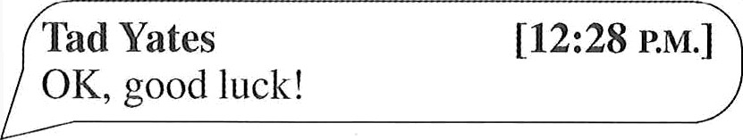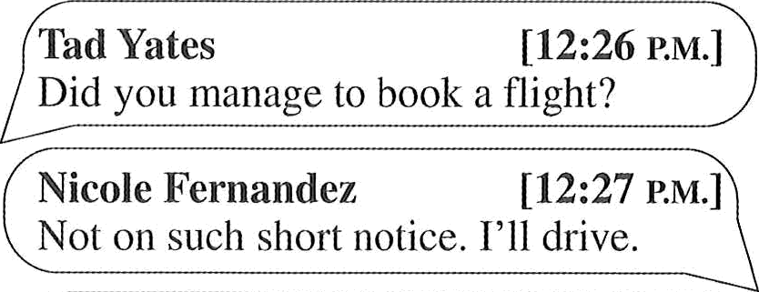

Nicole Fernandez

[12:23 P.M.]

Tad, this is just to let you know I’ll be in Amheist next Monday.

Tad Yates What’s going on?

[12:25 P.M.]

Nicole Fernandez

[12:26 .u.]

Our Amherst office requested a training session. Their insti uctoi has to take

an unexpected trip, and they need a substitute.

Tad Yates

[12:26 P.M.)

Did you manage to book a flight?

Nicole Fernandez

[12:27 P.M.]

Not on such short notice. I’ll drive.

Tad Yates

OK, good luck!

[12:28 P.M.]

1. What will Ms. Fernandez do next Monday? 154. At 12:27 P.M., what does Ms. Fernandez
   1. Teach a training course mean when she writes, “Not on such short
   2. Meet an instructor notice”?

##### Go on a vacation (A) She will not arrive on time.

* 1. Apply for a job (B) She will not travel by plane.
     1. She cannot accept an invitation.
     2. She cannot make a payment.

Questions 155-157 refer to the following e-mail.



|  |  |  |  |  |  |  |
| --- | --- | --- | --- | --- | --- | --- |
|  |  | Jake Taera <jtaeraOtritmail.com> | | | |  |
|  |  |  |  | Natalie Satter <nsa te | coldin s con > |
| from: |
|  |  | Information | | | |
|  |  | |  | |
| 30 September | |  |
|  |  | **Attachment:** | | d Coldings 1 | | | |
|  |  |  | | | |
|  |  | Dear Mr. Taera: | | | |  |
| Welcome to the Coldings Home Store family! You have been hired as a sales associate. Your training session begins on 8 October at 8:30 A.M. at the Auckland store, 42 Crossbill Road. Please report to Human Resources to begin your orientation as a Coldings Home Store team member. During your first two weeks with our company, you will learn about our team approach and the many benefits of working at Coldings Home Store. You will be WOl‘king from 8:30 A.M. tO 5:00 P.M. After training, you might be assigned to a different work shift and you will be eligible for benefits including flexible days off, sick days, and our employee discount. | | | |
| Please sign and return the attached document indicating your willingness to accept the position as sales associate. Please let me know if you have any questions or need directions. I look forward to seeing you at the Auckland store on 8 October. | | | |
| Sincerely, | | | | |
| Natalie Satter  Human Resources Coordinator | | | | |
|  |  | | | | |  |

1. What is the purpose of the e-mail?
   1. To thank an employee
   2. To provide job information
   3. To explain a new policy
   4. To announce a special sales event
2. According to Ms. Satter, what might happen after two weeks?
   1. Mr. Taera’s work schedule might change.
   2. Mr. Taera’s might be transferred to another location.
   3. The company might train Mr. Taera for a new responsibility.
   4. The company might mail Mr. Taera new benefits information.
3. What did Ms. Satter send with the e-mail?
   1. A store map
   2. An events calendar
   3. A list of benefits
   4. An employment agreement

Questions 158-160 refer to the following press release.

For immediate release Contact: Desmond Hawkes, Office of Public Relations

### Telephone: (02) 5555 6506 E-mail: [dhawkes@carlisle.org.au](mailto:dhawkes@carlisle.org.au)

New Exhibition at Sydney’s

Carlisle Art Museum

SYDNEY (3 June)—The Carlisle Art Museum’s latest exhibition, *Dee;J Waters,*

will open on 15 June. The exhibition will feature 38 realist and abstract paintings portraying the beauty and vastness of the world’s oceans. All the works were created by Australian artists based in Sydney, and among them will be six by the critically acclaimed oil painter Haiold Bernstein.

The exhibition will run until 15 July. Tickets are $10. Museum visitors may view the exhibition between 9 A.M. and 4 P.M. on Tuesdays, Wednesdays, and Thursdays, and between 2 P.M. and 9 P.M. on Fridays and Saturdays. On each day of the exhibition,

at least one of the artists will be present and available to answer visitors’ questions

about the creative process. Mi. Bernstein will be available on 30 June only.

On 23 July, the exhibition will open at the Muriel Art Gallery in Melbourne, where

ocean-themed paintings from Melbourne artists will be added to the collection.

1. What is one purpose of the press release? 160. What is implied about the exhibition in
   1. To advertise an upcoming art show Melbourne?
   2. To publicize paintings available for (A) It will be open to the public in the purchase evenings only.
   3. To profile an art gallery owner (B) It will include more paintings than the
   4. To announce the opening of a new exhibition in Sydney will.

museum (C) It will feature demonstrations of painting techniques by artists.

1. Who is Mr. Bernstein?

##### An art critic

* 1. A museum director
  2. A public relations specialist
  3. An artist

(D) It will include paintings of landscapes in

addition to paintings of oceans.

Questions 161-163 refer to the following e-mail.

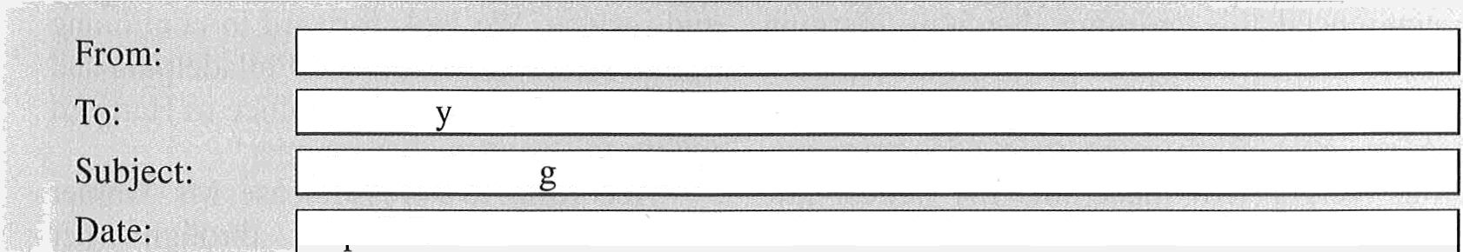

evaluation Hcrawfordds.com trosinsk Hmailssen.com

Crawford Desi n Contest

**\*E-mail‘**



|  |  |
| --- | --- |
|  | Aoril 2 |
|  |  |
| Dear Ms. Rosinsky,  Thank you for entering the Crawford Design Studio Awards Contest. Today we i eceived your project titled “Old Rexto Factory Restoration,” including a total of nine photographs and an 18-page description file. — [1] —. Your submission has been forwarded for further processing and has been assigned the entry number P1298.  — [2] —.  Your project will now be reviewed by a panel of judges, which consists of our in-house experts as well as outside designers. — [3] —. You will be able to check on the status of your entry via the “Submissions Being Processed” link in our Web site’s Main Menu.  Should you have any questions, please do not hesitate to call us. — [4] — Kind regards,  Crawford Design Studio |

161. What is the purpose of the e-mail?

1. To report missing documents
2. To inquire about building costs
3. To confirm receipt of materials
4. To request additional photographs

163. In which of the positions marked [1], [2], [3], and [4] does the following sentence best belong?

“Please use it when you contact us regarding your entry.”

162.

What is Ms. Rosinsky advised to do online?

1. Read the contest rules
2. Obtain a map and directions
3. Update her contact information
4. Track the progress of her submission

(A) [1]

(B) [2]

(C) [3]

(D) [4]

Questions 164-167 refer to the following article.

May 5—Boston law firm Warner and Arnes announced this morning that it is merging with the Philadelphia law firm Hamilton Jones to create Warner, Hamilton, and Associates. With more than 655 attorneys, the merger will make this the largest law firm in the northeastern United States.

“This is a welcome merger of two well- managed firms who share similar corporate cultures and philosophies,” said Andrea Warner, codirector of the former Warner and Arnes, who will serve as managing partner of Warner, Hamilton, and Associates. “Our combined expertise makes Warner, Hamilton, and Associates uniquely placed to

provide clients even higher levels of counsel and service. We look forwai’d to continuing our practices in Boston and Philadelphia and expect to open yet another office in Hartford within the next twelve months.”

According to a press release, Ms. Waiver has garnered attention through her representation of clients across the country in prominent cases involving workers’ rights, equal pay, and social justice.

The firm expects to keep all of its current lawyers and staff and will “combine management teams made up of partners from each firm to ensure a seamless transition,” the release said.

|  |  |  |
| --- | --- | --- |
| 164. Why was the article written? | 166. | What is suggested about Ms. Warner? |
| (A) To profile the career of a prominent |  | (A) She is based in Hartford. |
| lawyer   1. To promote legal services 2. To discuss the joining of two firms 3. To announce a firm’s relocation |  | 1. She plans to retire soon. 2. She sometimes offers free legal counsel. 3. She is well-known nationally. |
| 165. What does Warner, Hamilton, and | 167. | The word “seamless” in paragraph 4, line 4, |
| Associates plan to do? |  | is closest in meaning to |
| (A) Hire additional lawyers |  | (A) in a single piece |
| 1. Expand to a third city 2. Change its leadership 3. Close its Philadelphia office |  | 1. without problems 2. in close range 3. without hurry |

Questions 168-171 refer to the following e-mail.



TO:

**From:** | Thomas inclaren Odelicatessenmag.com

**Date:** Tuesd y Oc obei 2

**Subject:** Food Photog aphy ticles

Dear Ms. Bellandini:

I have some news regarding your article that is scheduled to be published in the next issue of *Delicatessen Magazine. —* [ l ] —. Yesterday, we learned that a major advertiser canceled their contract with us, and as a result, we will have to reduce the nmnbei’ of pages in our upcoming issue. This is extremely unfortunate, but we just do not have enough money without these ads to publish the magazine in its current format. — [2] —

We know that readers have enjoyed reading about your experiences in Italy. — [3]

While your eight-page story about working as a food photographer is excellent, in order to fit in the slimmer issue, it will need to be cut by about thirty percent. Although I sincerely hope you agree to having your article published in our upcoming issue, I will understand

if you would rather have the article published in full at a later time. However, I have to let you know that the magazine industry is not always the most stable business, and for this reason, I do not know if there will be space for your story in the future. — [4]

Please let me know as soon as possible what you would like to do. Should you agree to edit the story, I will need the new version by Monday.

Best regards,

Thomas McLaren, Editor-in-Chief

|  |
| --- |
| maria_bellandini O pweb.net |

1. What is implied about *Delicatessen Magazine?*

##### It plans to merge with another magazine.

* 1. It gives discounted subscriptions to staff.
  2. It relies on advertisements for funding.
  3. It offers long-term contracts to writers.

1. How would Ms. Bellandini most likely revise her article?
   1. By making it shorter
   2. By changing the topic
   3. By adding more information
   4. By including more images of food
2. What does Mr. McLaren NOT suggest to Ms. Bellandini?
   1. Her previous articles were well liked.
   2. She should submit her article to another magazine.
   3. Her article might not be published in full

at a later date.

* 1. She should notify him of her decision.

1. In which of the positions marked [1], [2], [3], and [4] does the following sentence best belong?

“Of course, this is your choice, and I will respect whatever decision you make.”

(A) [1]

(B) [2]

(C) [3]

(D) [4]



TfiST 3 95

Questions 172-175 refer to the following text-message chain.



Delroy Gerew (1:29 P.M.):

Hi, Ms. Chichester, we’d like to order another 10 shirts, featuring the company’s name, Magnalook, and its logo. We need four small, two medium, and four large sizes. Could you fill the order by Friday?

Nina Chichester (1:32 P.M.):

That’s two days from today, so a $75 rush-order fee will be added.

Delroy Gerew(1:34 P.M.):

How can we avoid the fee?

Nina Chichester (1:36 P.M.):

By choosing the standard 5-day production option. Your order would be ready Monday of next week.

Delroy Gerew (1:38 P.M.):

I guess it can’t be helped. Since we have employees starting this Friday and you open at 8:00 A.M., can I pick up the shirts at that time?

Nina Chichester (1:39 P.M.):

Pick-up time is normally after 1:00 P.M., but I’ll see to it they’re ready by 8:00 A.M.

Delroy Gerew (1:41 P.M.):

Thank you. Actually, my assistant will be picking them up.

Nina Chichester (1:42 P.M.):

That’s fine. Could you please e-mail me your logo again? The computer on which I had it stored crashed the other day and is awaiting repair.

Delroy Gerew(1:44 P.M.):

Will do. Thanks, and please charge the credit card you have on file for us.

1. What is suggested about the company Ms. Chichester works for?
   1. It currently has no large-sized shirts in

##### stock.

* 1. It has filled an order for Mr. Gerew before.
  2. It offers discounts on large orders.
  3. It is open every evening.

1. Why is Mr. Gerew ordering new shirts?
   1. Additional staff members have been hired.
   2. More were sold than had been anticipated.
   3. The company’s logo has been changed.
   4. The style currently in use has become outdated.
2. At 1:38 P.M., what does Mr. Gerew mean when he writes, “I guess it can’t be helped”?
   1. He will pay a $75 rush-order fee.
   2. He will ask his assistant to help him.
   3. He will meet Ms. Chichester at 1:00 P.M.
   4. He will select the standard production option.
3. What will Mr. Gerew likely do next?
   1. Provide payment information to Ms. Chichester
   2. Schedule a meeting with Ms. Chichester
   3. Send an e-mail to Ms. Chichester
   4. Fix Ms. Chichester’s computer

Questions 176-180 refer to the following e-mail and notice.



E-Mail Message



|  |  |
| --- | --- |
| To: staffmailinglist Hcoltonmedica1.org  Front: Melvin Myei’s <nrnyers O coltonmedical.org> Date: June 10  Subject: Parking ai'ea reassignment | |
| Dear Colleagues:  I just want to remind everyone that crews will begin construction on the new Colton Medical Nutrition Center on June 18.  Effective June 15, parking areas F and G will be closed until August 20, whelk construction is expected to be completed. Staff cui i ently assigned to park in areas F and G will be given temporary “guest” parking stickers and must park in the guest-parking garage. The Property Maintenance Office will place stickers in staff mailboxes by 4 P.M. today. The sticker should be displayed on the driver’s side window of the vehicle.  A construction access road will be created by closing the entrance and exit roads to parking areas F and G. This will also block access to the security building and the pond. However, a temporary alternative entranceway to those locations will be created. To help eliminate excessive traffic, please visit those places only when absolutely necessary. Take note that the Information Center at the main entrance will remain open during construction.  Please e-mail me directly with any questions regarding parking stickers. Sincerely,  Melvin Myers Property Maintenance |  |
|  |

|  |  |
| --- | --- |
| WELCOME TO COLTON MEDICAL CAMPUS INFORMATION CENTER PLEASE CHECK IN BEFORE PROCEEDING |  |
| ATTENTION STAFF:  I*ARKING AREAS F & G CLOSED UNTIL SEPTEMBER 10  Staff members who normally use these areas and who have not yet received d t 'mgurdry parking sticI‹er should request unu at the security station. A valid access carcl and staff I.D. are required.  Cars will be immediately towed away if parked next to pedestrian areas, inc luding al I walkways, temporary rest areas, and construction tents.  Owners of cars barked in the garage without a sticker displayed on the window will be finecl $2 ñ per day.  Security officers are available to assist ycu. |  |

1. Why are parking areas being closed?
   1. They are being resurfaced.
   2. They are being reserved for guests.
   3. An outdoor event will be held on them.
   4. A construction project is scheduled to begin.
2. What changed after the e-mail was sent on June 10 ?
   1. Which parking areas are being closed
   2. Where staff should park their vehicles
   3. Where parking stickers should be displayed
   4. How long some parking areas will be

177.

According to the e-mail, who will receive a temporary parking sticker?

1. Anyone who is visiting the medical campus
2. Anyone who usually parks in areas F and G
3. Anyone who usually parks in the parking garage
4. Anyone who requests one from the maintenance office

closed

1. According to the notice, why might a staff member’s car be towed?
   1. If it is parked near a walkway
   2. If it is parked in the visitors’ area
   3. If it does not display a parking sticker
   4. If it is parked in the garage after August 20

178. Why should staff members limit their visits to the security building?

1. So that visitors can enjoy the pond
2. So that fewer cars will be in the area
3. So that security staff can monitor traffic
4. So that visitors can get to the Information Center

Questions 181-185 refer to the following survey and e-mail.

# SURVEY “

### Please take a few minutes to complete this survey about your shopping experience at Woodi uff’s. Indicate your answer using the 5-point scale to the right of each statement. (I = Str ongly Disagree, 2 = Disagree, 3 = No Opinion, 4 = Agree, 5 = Strongly Agree)

|  |  |  |  |  |  |
| --- | --- | --- | --- | --- | --- |
| The store was clean and organized in appearance. | 1 | 2 | 3 | 4 | 5 |
| There was a wide selection of items in my size. | 1 | 2 | 3 | 4 | 5 |
| There were dressing rooms available for me to use. | 1 | 2 | 3 | 4 | 5 |
| The salespeople were courteous and attentive to me. | 1 | 2 | 3 | 4 | 5 |
| The items were priced well compared to other stores. | 1 | 2 | M 3 | 4 | 1. 5 |
| I am satisfied overall with my experience at Woodruff’s. | 1 | 2 | 3 | 4 | 5 |

Amount you spent on this purchase: 60

Age (optional): 16-25 26-35 36-45 46-55 56-65 66+

#### Name (optional):

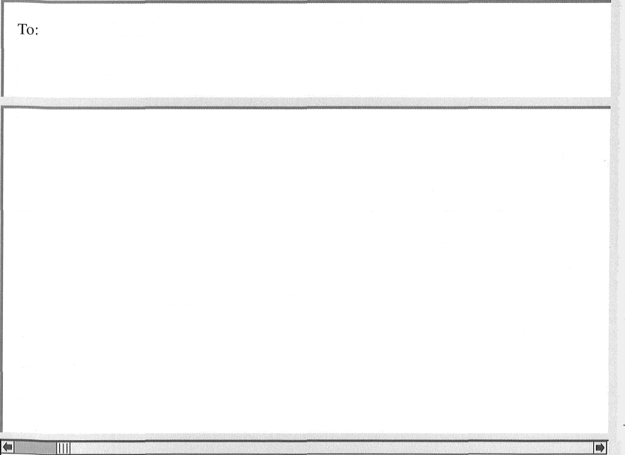

TCwoonsuela

es E-mail (optional): ca orres81 a ail co au

|  |  |  |
| --- | --- | --- |
| ~~—~~ I--Mail Message | | |
| From: Customer Service <custserv H woodruff.co.au> Consuela Torres <catorres81 H aumail.co.au>  Date: Friday, 27 April 2:40 P.M.  Subject: Survey Attachment: d Voucher |  | |
| Dear Ms. Toi res: |  |  |
| Thank you for taking the time to complete a survey about your recent experience at Woodruff’s. We appreciate that so many people took the time to provide us with feedback since it helps us to improve the quality of our service. |
| We were happy to 1eai’n that your overall experience shopping at Woodruff’s was a positive one. However, we were sorry to see that you shared one area of dissatisfaction with a significant proportion of the customers who responded to the survey. I want you to know that we are taking the survey results seriously. We plan to improve this area with training soon. |
| As an apology for our failure to meet high standards in all areas, I have attached a Voucher for 15% *of* a future purchase (good for one year) at any of our three Clarksville locations. We look forward to serving you in the future. |
| Sincerely, |
| Marietta Passante |
|  |  | |

1. What type of business is Woodruff's?
   1. A computer software company
   2. A clothing store
   3. A mobile-phone service provider
   4. A consulting firm
2. With what statement about Woodruff’s would Ms. Torres most likely agree?
   1. It is located close to her home.
   2. It has a large staff.
   3. It is relatively inexpensive.
   4. It is open later than other businesses.
3. In the e-mail, the word “appreciate” in paragraph 1, line 2, is closest in meaning to
   1. increase

##### order

* 1. understand
  2. value

1. What most likely is Woodruff’s planning to do?
   1. Teach its employees to be more friendly and helpful to customers
   2. Make the workplace cleaner and more organized
   3. Open an additional location in Clarksville
   4. Offer a discount voucher to all customers who complete a survey
2. What is suggested about the survey?
   1. It has been taken by many customers.
   2. It was created by Ms. Passante.
   3. It is accessible on the company Web site.
   4. It has been in use for one year.

Questions 186-190 refer to the following invoice and e-mails.



| October 17

To: From: Subject:

Date:

”E-mail”

Dear Mr. McGivern,

I received my October order, but there were some errors. I received 20 dinner plates instead of 40, and seven water goblets air ived with cracks in the glass. Have you switched shipping carriers recently?

I have been a loyal customer since you opened five years ago, and never before have I experienced problems with an order. Incidentally, you might like to know that I spoke this morning with Ed Salek, owner of nearby Salek’s Café. He mentioned that his last delivei’y from you had some mistakes too.

How soon can you fix my order? I have three parties coming up next week, so I need these items quickly.

S incerely, Deshauna Jacques

|  |  |  |  |  |  |
| --- | --- | --- | --- | --- | --- |
| McGivern Wholesale  1486 Beden Trail, Brampton ON L6R 2 K7 905-555-0158 • [www.mcgivernwhoIesaIe.ca](http://www.mcgivernwhoIesaIe.ca/)  Ordered By: Deshauna’s Creations  Order Date: October 12 | | | | | |
| Item | Item Name | Quantity | Price Each | Amount | |
| 14L  17P | 3mtablelinens, cream  25 cm dinner plates, pale blue | 4  40 | $26.00  $4.40 | $104.00  $176.00 | |
| 18S | 50cm serving dishes, white | 20 | $7.95 | $159.00 | |
| 21G | 350mI water goblets, amber | 40 | $3.25 | $130.00 | |
| Subtotal | | | | | ›569.00 |
| Tax (NST) | | | | | ›73.97 |
| Shipping | | | | | ›30.00 |
| Total | | | | | ›672.97 |
| *Payment is due upon receipt.* | | | | | |

|  |
| --- |
| Pete McGivern <pete.mcgivern Hmcgivernwho1esale.ca> |
| | Deshauna Jacques <deshaunajacques Odeshaunascreations.ca> |
| | October order |

|  |
| --- |
| Deshauna Jacques <deshaunajacquesOdeshaunascreations.ca> |



##### Why was the first e-mail sent?



To:

**From:** | Pete McGivern <pete.mcgivern W mcgivernwholesale.ca>

**Subject:** Re Octobei rder

**Date:** October 17

Dear Ms. Jacques,

I was very sorry to learn about your order, and about Mr. Salek’s as well; I will extend my apology to hint today. You are a valued customer, and I am embarrassed that you received such a poor shipment. We are in the middle of moving to a new warehouse, and it has not gone as smoothly as I had hoped. Regardless, I want to make amends as soon as possible. I have put in an order to correct the mistakes, and I hope you will accept a 15 percent discount on your next shipment. Just use code l5D when placing your order.

Please let me know if there is anything else I can do to correct this. Yours sincerely,

Pete McGivern

* 1. To ask for customer feedback
  2. To seek a solution to a problem
  3. To request a refund on an item
  4. To cancel an order for tableware

1. What item was received damaged?
   1. 14L
   2. 17P
   3. 18S
   4. 21G
2. In the second e-mail, the word “extend” in paragraph 1, line 1, is closest in meaning to
   1. offer
   2. delay
   3. continue
   4. increase
3. What is NOT indicated about McGivern Wholesale?
   1. It does business with restaurants.
   2. It is changing the location of a facility.
   3. It has been operating for five years.
   4. It is revising its price list.
4. What will McGivern Wholesale give to Ms. Jacques?
   1. A rebate on shipping charges
   2. An extra package of table linens
   3. A reduced price on her next order
   4. An updated invoice

Questions 191-195 refer to the following form, notice, and e-mail.



|  |  |  |
| --- | --- | --- |
| Date: March 15  450 Matilda Drive Cost Estimate No.: 50190  Lexington, Kentucky 40502  Prepared for: Jenny Choi, 518 Buffalo Springs Road Prepared by: Gabriel Nunez | | |
| Description | Amount | Cost |
| Unglazed ceramic floor tiles (H $2.49/tile) | 400 | $996.00 |
| Premium bi‘ight white grout (H $32.99/gallon) | 5 | $164.95 |
| Labor for preparation, installation, and cleanup (H $35/hour) | 16 | $560.00 |
| ESTIMATE TOTAL $1,720.95 | | |
| All estimates are valid for one month unless otherwise specified. | | |

N w Lexin ton C Ordinance

As of March 30, all construction companies must have a building permit ($100 for residential buildings; $300 for commercial buildings) before beginning a renovation project for each client. To complete an application for your construction project, contact City Hall at 859-555-0103.





TO'

**FROM:**

ate:

S b e

Gab iel Nunez < nune

eddfo dcon co >

Jenny Choi <jchoi86 ci y ail co >

MFJ iday A i1 2 10 12 A

Pe

its

Dear Mr. Nunez:

I’m writing concerning the job in my dining room that I’d like to contract you for. I’d like work to begin on April 10, but after looking at the estimate you sent me, I have a question about your calculation of the total cost. Specifically, does your estimate take into account any permits that would be needed for the job? A colleague told me that there is an ordinance that went into effect last month requiring building permits for any renovation project. I really liked the job you did installing carpeting and painting in my living room last year, and I would prefer to work with a company that I know. However, I am on a tight budget, so I need to consider the charge for the building permit in the overall cost of the project. Could you please get back to me at your earliest convenience?

Sincerely, Jenny Choi

|  |  |  |
| --- | --- | --- |
| 191. On April 10, what work does Ms. Choi want Mr. Nunez to do for her? | 194. | In the e-mail, the word “contract" in paragraph 1, line 1, is closest in meaning to |
| 1. Deliver furniture 2. Install tiles 3. Clean the living room carpets 4. Paint the dining room walls |  | 1. reduce 2. retain 3. collect 4. purchase |
| 192. What will happen after April 15 ? | 195. | What does Ms. Choi indicate about |
| (A) Ms. Choi’s application will be reviewed. |  | Reddford Construction? |
| 1. Ms. Choi will receive a final bill. 2. The new city ordinance will go into effect. 3. The cost estimate will become invalid. |  | 1. She has hired them for a job before. 2. She needs to reschedule an appointment with them. 3. She thinks that their prices are too high. 4. She believes that they bought too many |

##### 193. How much will likely be added to Ms. Choi's estimate?

(A) $32.99

(B) $35.00 (C) $100.00 (D) $300.00

tiles.



Questions 196-200 refer to the following article, e-mail, and text message.

*Cardiff Daily* ***Times***

##### In Brief—20 March

As reported earlier this year, Gold Kettle Grocery is opening an additional regional distribution centre in Cardiff. Construction was postponed for a time because of an unanticipated problem related to the ground conditions on the site. However, the problelii has been resolved, and the 40,000-square- metre centre should be fully operational in June. The grand opening is planned for the



| 26 June

|

To: From: Subject: Date:

Attachment:

**\*E-mail“**

Dear Myles:

Thanks for giving me a lift to the grand opening earlier this month. I do not believe I have ever seen such a well-planned event. We should send Ping Chen something to show him our appreciation for organising it.

Now that the centre in Cardiff has been open for a few weeks, I think we should consider hiring a company that forwards automatic notifications to employees’ mobile phones. Such a service would allow us to get messages to them quickly and also prevent mistakes with shipments. I have a contact who has worked in customer service at Calls For You. I think it’s a good company, but Raven Notifications also looks good, and their rates are lower. I have attached information about both companies to help you decide which one we might use. Let me know what you think.

Sincerely, Raadhika Baral

fourth of June. The wai’ehouse has a special area with state-of-the-art equipment to store foods that need to be kept frozen or cool. The site will also include loading bays and offices.

The distribution centre is expected to create more than 400 new jobs, according to Myles Simler, vice president of operations. Because of the size and scope of the project, a variety of jobs will be needed, from warehouse loaders and drivers to clerical positions.

|  |
| --- |
| Myles Siinler <msimlerOgo1dkettle.co.uk> _ |
|  |
| Raadhika Baral <rbaral H goldkettle.co.uk> |
| Information |

|  |
| --- |
| d Notification comparison |





Raven Notifications

11:43 A.M.

To Gold Kettle Employees—The frozen-goods shipment scheduled to arrive on Tuesday will not arrive until Wednesday. Employees who had volunteered to work additional hours on Tuesday night

at the Cardiff distribution centre will not be needed. However,

we will need additional help for the overnight shift on Wednesday night. If you are interested in working additional hours at that time, please contact Becca Johnston in Human Resources.

1. What is the purpose of the article?
   1. To provide an update on a local project
   2. To discuss state-of-the-art warehouse equipment
   3. To report on local businesses that plan

##### to hire more workers

* 1. To explain difficulties encountered on a construction project

1. In the article, the word “scope” in paragraph 2, line 4, is closest in meaning to
   1. instrument used for viewing
   2. evaluation
   3. time of completion
   4. extent
2. What is most likely true about the Cardiff distribution center?
   1. It had a problem with food storage.
   2. Its grand opening was successful.
   3. Mr. Simler was recently hired there.
   4. Ms. Baral was unhappy with its service.
3. What company was chosen by Mr. Simler?
   1. The company that Ms. Baral’s contact works for
   2. The company with the most reliable customer-service representatives
   3. The company that has lower rates than a competitor
   4. The company with an overnight call center
4. What does the text message ask employees who want additional work to do?
   1. Arrive on Tuesday night
   2. Contact the personnel office
   3. Reply to the message with the hours they can work
   4. Go to a different distribution center



### Stop! This is the end of the test. If you finish before time is called, you may go back to Parts 5, 6, and 7 and check your work.